**PROPERTY SALES OBSERVATIONS, Q1 2007 – Q2 2023**

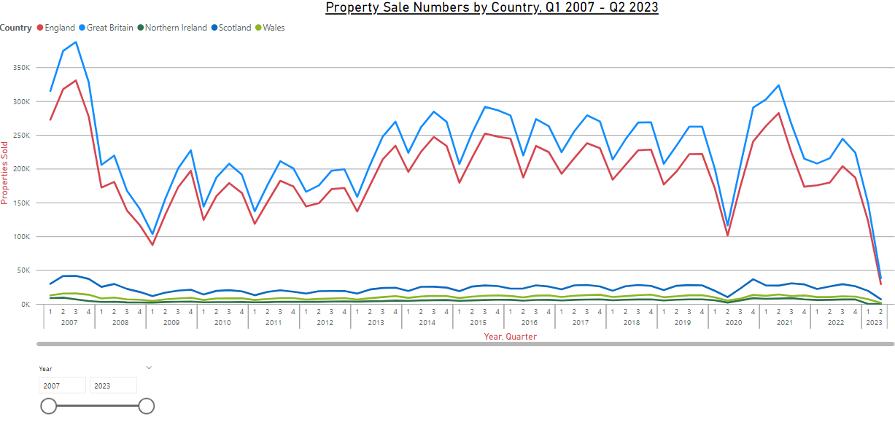

Q3 2007 – Q1 2009

Property sale numbers underwent a sustained and substantial reduction from approx. £387k down to £103k. This is likely due to the global financial crisis.

**MORTGAGE INTEREST RATE & CIPH INFLATION OBSERVATIONS, Q1 2007 – Q2 2023**

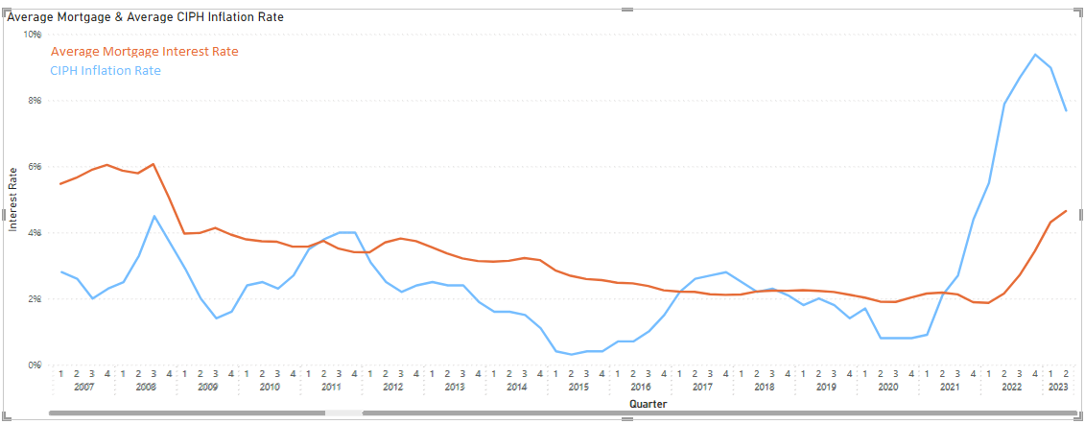

1. **Stamp Duty Changes:**
   * **2008:** In September 2008, the UK government temporarily increased the threshold for paying stamp duty to £175,000 for one year. This was a response to the global financial crisis to stimulate the housing market.
   * **2010:** In the 2010 Budget, the government introduced a stamp duty holiday for first-time homebuyers on properties priced up to £250,000. This lasted until March 2012.
   * **2014:** In December 2014, the government introduced a new stamp duty system, known as the Stamp Duty Land Tax (SDLT) reform, which replaced the slab system. This change resulted in a more progressive tax, with higher rates for properties in higher price bands.
   * **2020:** During the COVID-19 pandemic, the government announced a temporary stamp duty holiday on properties up to £500,000. This holiday was extended until June 30, 2021, and then tapered off until September 30, 2021.
2. **Help to Buy Schemes:**
   * **2013:** The Help to Buy Equity Loan scheme was launched in England in April 2013. It provided equity loans to first-time buyers and home movers to help them purchase new-build homes. A similar scheme was also introduced in Scotland in 2013.
   * **2014:** A separate Help to Buy Mortgage Guarantee scheme was introduced in England in January 2014. It aimed to support borrowers with smaller deposits by providing a government guarantee to lenders.
   * **2016:** The Help to Buy ISA scheme was launched in December 2015 and became available to first-time buyers in the UK in early 2016. It allowed individuals to save money for a home deposit, with the government providing a bonus when they purchased a property.
   * **2021:** The Help to Buy Equity Loan scheme in England was extended to March 2023. There were also regional variations of the scheme in Scotland and Wales.
3. **Other Initiatives:**
   * **2018:** The government introduced the "First Homes" scheme in England, which aimed to provide discounted homes to local first-time buyers and key workers.
   * **2021:** The UK government announced a new 95% mortgage guarantee scheme in the Spring 2021 Budget. This scheme aimed to help first-time buyers and existing homeowners purchase homes with a 5% deposit.